GRANARD MUNICIPAL DISTRICT

Corporate Affairs,
Aras an Chontae,
LONGFOIRT.

20th September 2016.

To: Each Member of Granard Municipal District.

Dear Member,

I refer to Agenda forwarded to you for Granard Municipal District meeting in
Granard Community Library on Tuesday, 27th September 2016 at 3.30 p.m.

I set out, hereunder, two additional items for consideration at the meeting.

Yours sincerely,
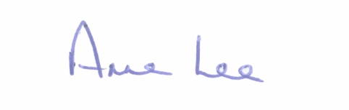

_______________
Anne Lee,
Meetings Administrator.

1. Consideration of the Taking in Charge of the “McArt Meadows, Leitrim Cross, Co. Longford - details attached.

2. Consideration of Adoption of Part 8 Report (Planning and Development Regulations 2001) (as amended) in respect of proposal to carry out a development referred to as – 1 No. 3 Bedroom Single Storey Bungalow at Drumeel, Moatfarrell, Co. Longford - details attached.

::::::::::::::::::::::::::::::::

